
2011 Hunting Season . 3^{nrd}Newsletter

Dear all,

Our 3rd newsletter comes at a time when thankfully the winter has departed and summer is truly here with beautiful sunny warm days. With the nice weather and thinning bush we have been fortunate enough to experience excellent hunting. As predicted, with less water and thick bush the buff hunting has been great and we shot some fantastic bulls.

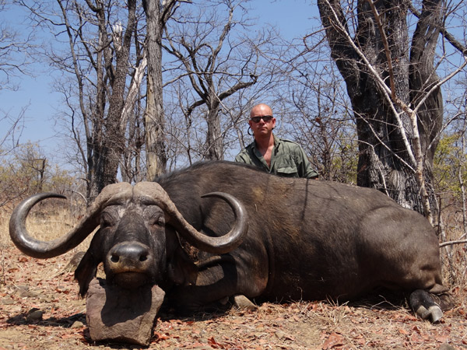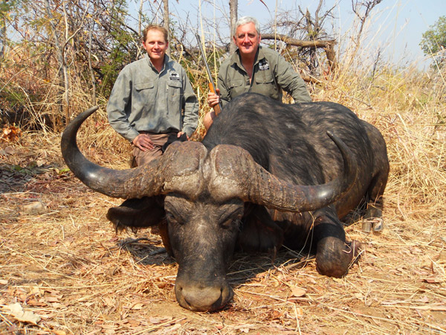
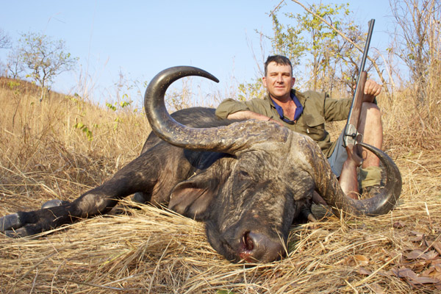
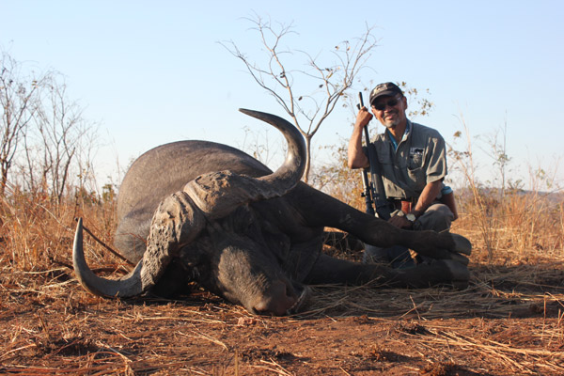

From top left: Brett Barnes 43” buff, Mike Wittet 44” buff,
Takumaro Ikeguchi 40” buff & Scott Brown 45” buff.

With temperatures warming up we are happy to have also finished the bulk of the cat hunts with some nice leopard and lioness being taken in Dande, much to the relief of the local villagers where man eaters accounted for over 13 deaths last season!

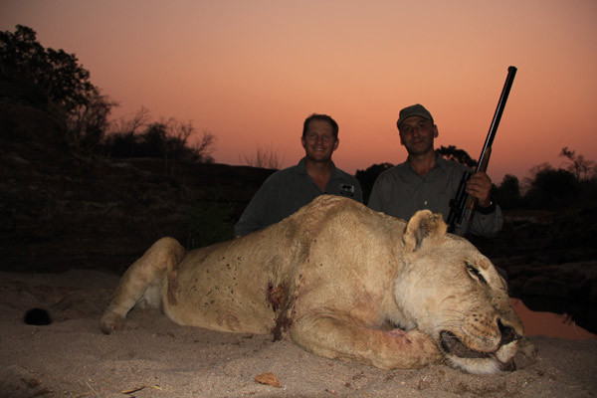
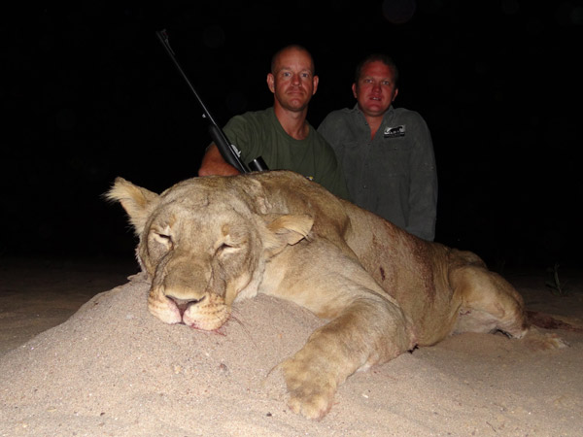
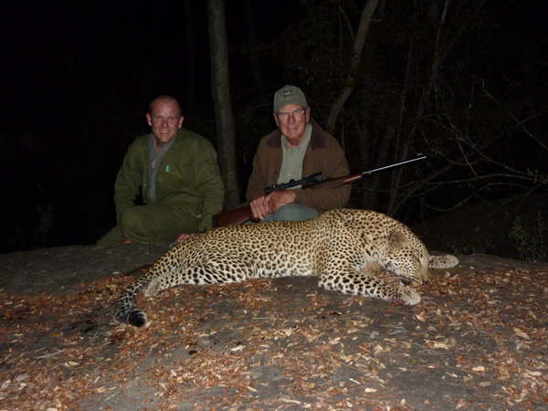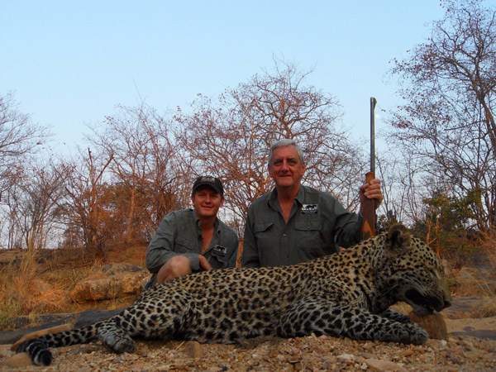

From top left: Momchill, Brett Barnes, Jerome Haner & Mike Wittet

We unfortunately received the very sad news of the untimely passing of one of our most loyal clients and friend Peter Sharpe. Peter and Shaun have been with CM right from the beginning. Peter had an amazing life and selflessly dedicated a lot of it to the help of the Aborigine people in Australia- not only will he be sorely missed by them but by everyone who knew him including the whole CM team. The saying “ the world is lesser place with out an individual” does not apply to many but with regards to Peter this certainly is true. He was a man among men and our sincere condolences go to his family and also to Shaun who shared the most amazing friendship with Peter. We have many wonderful memories of Peter and Shaun’s safaris with us!
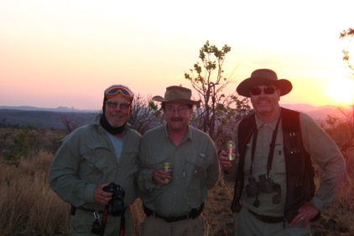
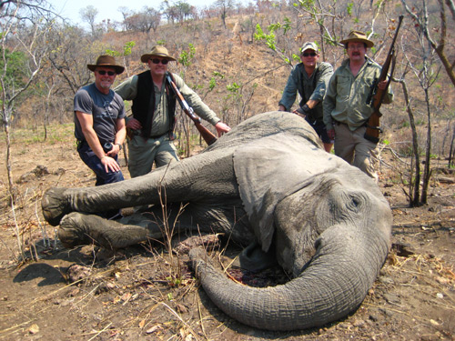
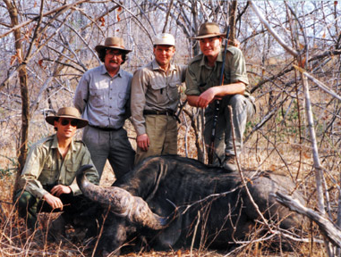

From left:

Martin Harris, Dr Peter Sharp, Mathew Burgess, Dr Shaun Leighton, 1991.

Mathew, Shaun, Rich & Peter with his tuskless, 2010.

Sundowners -end of hunt Sean Mathew and Peter, 2010.

On a happier note CMS have been looking for an area where we can offer quality dangerous game hunting with the opportunity of taking large numbers of plainsgame in the same area. While Dande and Makuti are certainly considered the best dangerous game areas in the valley, being in the valley, means that your plainsgame opportunities are limited.

We are very excited to tell you that we have secured sole rights to hunting Hammond Area in The Save Conservancy. This beautiful area is considered the very best area in the low veld for BIG buffalo. Alan has just finished off a hunt there and said he saw several bulls easy over 40” and one or two monsters in the upper 40s!! Not only are the buff outstanding but the plainsgame and leopard are brilliant as well.

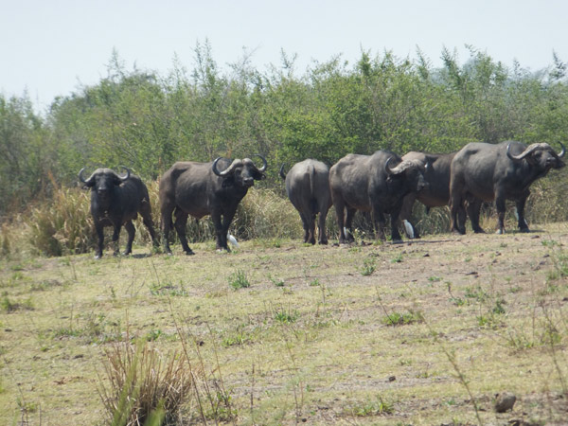
We have an elephant and a lion that alternate every year also. It goes with out saying that the lions are possibly the best free range lions available while the average elephant trophy size is already over 40lbs. Considering that these elephant are still relatively young it will not be long before some outstanding trophies come out of the Save. This is thanks to great genes from the initial elephants bought in from Gonerazou National Park. The camp is 5 star and for those of our clients that have hunted Dande and Makuti it will offer a very exciting new hunting opportunities!!!

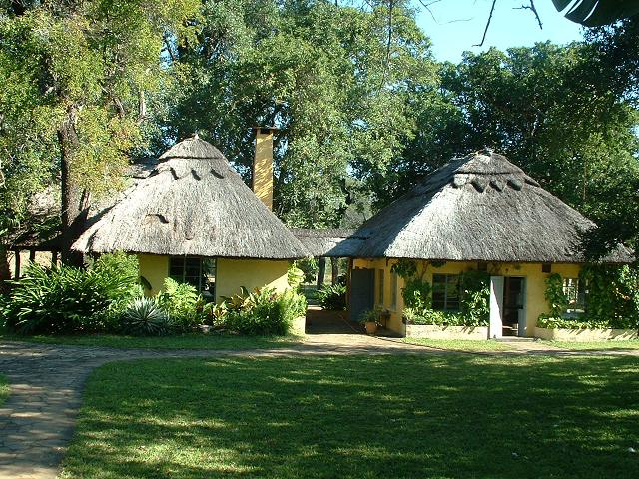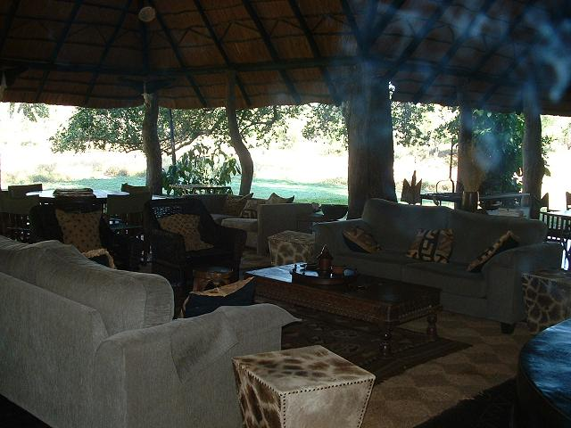

Hammond Camp in the Save Valley Conservancy

We will be looking forward to seeing you all at the shows again this year where we will be selling our new DVD “ The Essence Of Elephant Hunting” which I think you will all enjoy. Until our final news letter,

Happy hunting from the CMS Team

